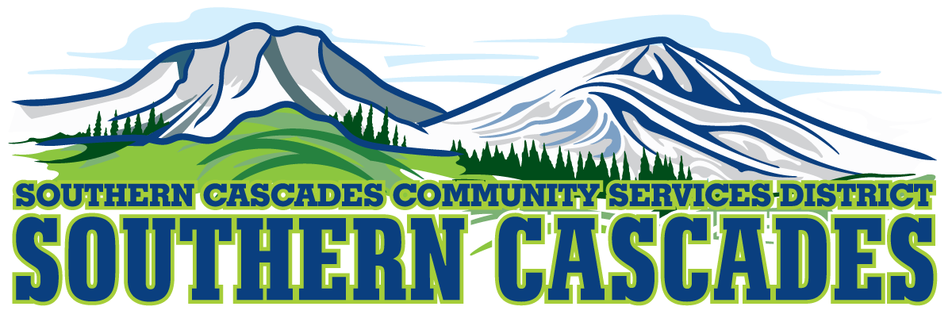
Conference Room
Southern Cascades Operations Base and Training Center
205 Ash Valley Road, Adin, CA 96006
January 15, 2024 5: 00 PM
Regular Board Meeting Agenda

- Call to Order

- Pledge of Allegiance

3.0 Roll Call and Establishment of a Quorum of the Board of Directors
4.0 Deletions /Additions and Approval of Agenda
5.0 Public Comment: This is the time set aside for citizens to address the Board on matters on the consent agenda and matters not otherwise on the agenda. Comments should be limited to matters within the jurisdiction of the Board. If your comment concerns an item shown on the agenda. Please address the Board after that item is open for public comment. By law, the Board cannot take action on matters that are not on the agenda. The chair reserves the right to limit the duration of each speaker to three minutes. The speaker may not cede their time.
Agenda items with times listed, will be considered at that time. All other items, will be considered as listed on the agenda or as deemed necessary by the Chairperson.

6.0 CLOSED SESSION-
6.1 Per Government Code § 54957, Public Employee Performance Evaluation- District General Administrator
6.2 Per Government Code § 551.071, Real Property Negotiations
7.0 Reconvene to Open Session
7.1 Instruction is given to staff, resultant of the Closed Session
8.0 Election of Board Officers for 2023
8.1 Board Chair
8.1.1 Nominations for Board Chair
8.1.2 Election of Board Chair
8.2 Board Vice Chair
8.2.1 Nominations for Board Vice Chair
8.2.2 Election of Board Vice Chair
8.3 Board Secretary
8.3.1 Nominations for Board Secretary
8.3.2 Election of Board Secretary
8.4 Board Treasurer
8.4.1 Nominations for Board Treasurer
8.4.2 Election of Board Treasurer
9.0 Reports
9.1 Finance Committee Report
9.2 CFO Report
9.3 District General Administrator Report
10.0 Consent Agenda
10.1 Approve regular board meeting minutes for December 18, 2023
10.2 Approve a refund of $65.00 for an overtax of 1 parcel 018-050-017-510 to assessed owner Vonderlinden, Gary & Silvia Trust
11.0 Action Items
11.1 Accept the December 2023 Financials

12.0 Discussion
12.1 Discuss timeline for proceeding with the purchase of 2 Subaru Crosstreks- Financed by Stefan Morton of CSDA Finance Corporation
12.2 Discuss creation of vehicle replacement plan
13.0 Adjournment

Parties with a disability as provided by the American Disabilities Act who require special accommodations or aides in order to participate in the public meeting should make the request by calling 530 299 3110 at least 24 hours prior to the meeting.
Posted at Southern Cascades Operations Base and Training Center Foyer and the SCCSD Web Site January 12, 2024.

