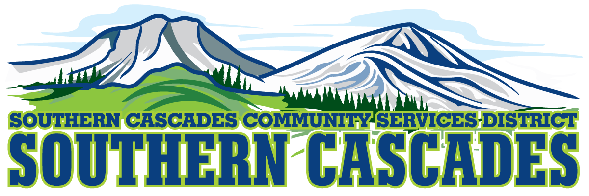
205 Ash Valley Road, Adin, CA 96006
Finance Committee Meeting
March 20, 2023 4:00 PM

1.0 Call to Order
2.0 Pledge of Allegiance
3.0 Approval or Additions/Deletions to Agenda
4.0 Public Comment: This is the time set aside for citizens to address the Board on matters on the consent agenda and matters not otherwise on the agenda. Comments should be limited to matters within the jurisdiction of the Board. If your comment concerns an item shown on the agenda, please address the Board after that item is open for public comment. By law, the Board cannot take action on matters that are not on the agenda. The chair reserves the right to limit the duration of each speaker to three minutes. The speaker may not cede their time.
Agenda items with times listed will be considered at that time. All other items will be considered as listed on the agenda or as deemed necessary by the Chairperson.
5.0 Discussion:
Revised 22-23 Pay Scales
EMS Budget based on using QRV
Cash Reserve
School Appraisal
Current Budget – Confirm USDA Grant is removed…
Director of Operations
Human Resources

6.0 Recommend Approval of February 2023 Financials
7.0 Adjournment
Parties with a disability as provided by the American Disabilities Act who require special accommodations or aides in order to participate in the public meeting should make the request by calling 530-299-3110 at least 24 hours prior to the meeting. Parties requesting Board Packet should make that request by calling 530-299-3110. You may also contact the district manager by email at manager@southerncascades.org

Posted at Southern Cascades Operations Base and Training Center Foyer and the SCCSD Web Site Friday March 17, 2023.

