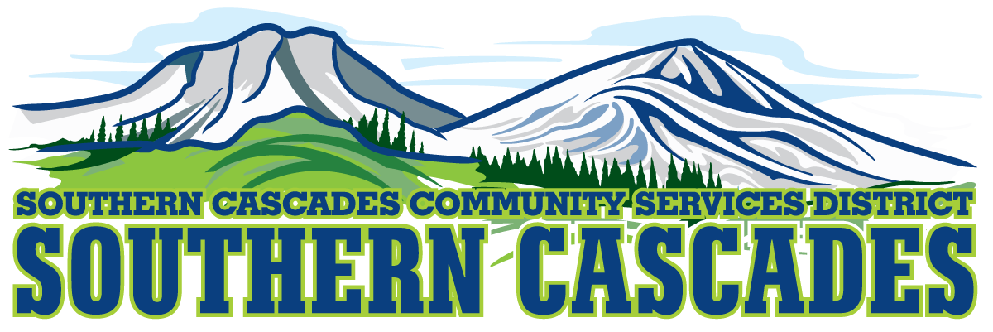

Conference Room
Southern Cascades Operations Base
Training and Conference Center
205 Ash Valley Road, Adin, CA 96006
January 14, 2019 5:30 pm
BOARD MEETING
AGENDA
- Call to Order

- Pledge of Allegiance

- Deletions/Additions and Approval of Agenda
4.0 Public Comment: This is the time set aside for citizens to address the Board on matters on the consent agenda and matters not otherwise on the agenda. Comments should be limited to matters within the jurisdiction of the Board. If your comment concerns an item shown on the agenda. Please address the Board after that item is open for public comment. By law, the Board cannot take action on matters that are not on the agenda. The chair reserves the right to limit the duration of each speaker to three minutes. The speaker may not cede their time.
Agenda items with times listed will be considered at that time. All other items will be considered as listed on the agenda or as deemed necessary by the Chairperson.

5. CFO Report

6.0 Information / Discussion
Information exchange with Stakeholders regarding SEMSA’s 180 day notice to terminate their contract with Southern Cascades CSD.
Participants: Staff
Stake Holder Agencies
Public
Board
7.0 SEMSA Report

8.0 CLOSED SESSION; Conference with legal Counsel- Initiation of Litigation
Government Code Section 54956.9 Number of Cases 1

9.0 RETURN TO OPEN SESSION

9.1 Report of Actions taken in Closed Session

10.0 CONSIDERATION / ACTION

Appoint Ad-Hoc Committee to develop delivery alternatives for operation of EMS within Southern Cascades CSD with an offer to make this a joint committee with Mayers Memorial Hospital District.

11.0 Election of Board Officers for Fiscal Year 2019

12.0 Board Committee Appointments

13.0 District Manager Report

14.0 Board Reports

15.0 Adjournment

Parties with a disability as provided by the American Disabilities Act who require special accommodations or aides in order to participate in the public meeting should make the request by calling 530 299 3110 at least 48 hours prior to the meeting.

Posted at Southern Cascades Web Site, Operations Base and Training Center Foyer and Adin Post Office Bulletin Board January 11, 2019
.

