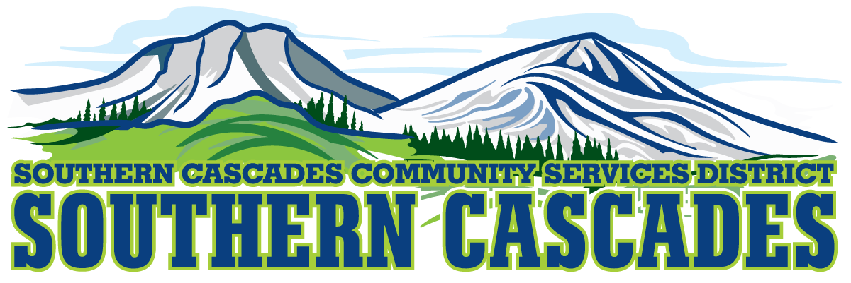
Conference Room
Southern Cascades Operations Base and Training Center
205 Ash Valley Road, Adin, CA 96006
August 15, 2022 5:30 pm
Regular Board Meeting
AGENDA

- Call to Order

- Pledge of Allegiance

3.0 Roll Call and Establishment of a Quorum of the Board of Directors
4.0 Deletions /Additions and Approval of Agenda
5.0 Public Comment: This is the time set aside for citizens to address the Board on matters on the consent agenda and matters not otherwise on the agenda. Comments should be limited to matters within the jurisdiction of the Board. If your comment concerns an item shown on the agenda. Please address the Board after that item is open for public comment. By law, the Board cannot take action on matters that are not on the agenda. The chair reserves the right to limit the duration of each speaker to three minutes. The speaker may not cede their time.
Agenda items with times listed, will be considered at that time. All other items, will be considered as listed on the agenda or as deemed necessary by the Chairperson.

6.0 Consent Agenda
6.1 Approve Minutes for the following meetings;
Regular Board Meeting July 18, 2022
Special Board Meeting August 8, 2022

7.0 CFO Reports on June 2022 and July 2022 Financial Statements

8.0 Consideration/Action
8.1 Approve Delegation of Authority to Grants Manger to submit USDA Grant Loan application (s) over District General Administrators signature at the Fifty-Five percent Grant Level.
8.2 Review and Approve June 2022 Financials
8.3 Review and Approve July 2022 Financials
8.4 Review and Approve 2022-2023 HTS Rate Schedule

9.0 Information and Discussion:
9.1 Finances and potential staffing model change due to cash flow.

10.0 Correspondence

11.0 District General Administrator Report

12.0 Board Reports

13.0 CLOSED SESSION
13.1 Per Government Code 54957, Public Employee Performance Evaluation District General Administrator.

14.0 Resume Open Session

15.0 Consideration/Action
15.1 Approve Any Formal Action to be taken by board as result of closed session.

16.0 Adjournment

Parties with a disability as provided by the American Disabilities Act who require special accommodations or aides in order to participate in the public meeting should make the request by calling 530 299 3110 at least 24 hours prior to the meeting.

Posted at Southern Cascades Operations Base and Training Center Foyer and the SCCSD Web Site Wednesday August 12, 2022.

