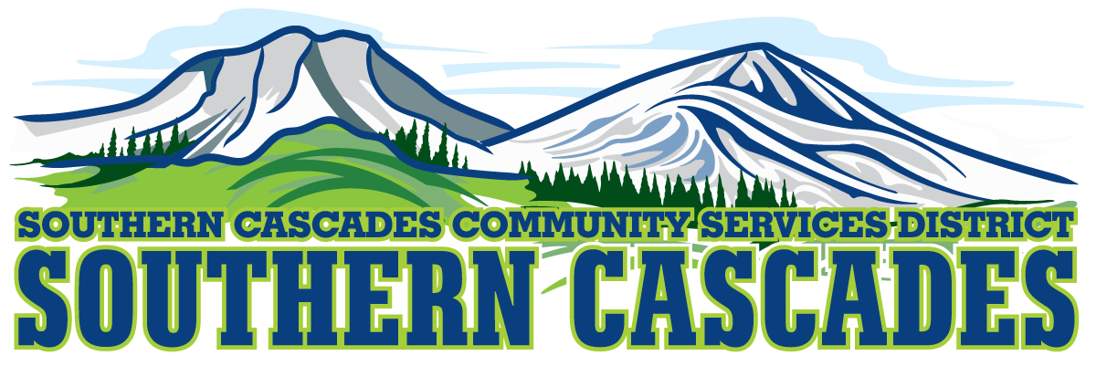
Conference Room
Southern Cascades Operations Base and Training Center
205 Ash Valley Road, Adin, CA 96006
January 20, 2025, 5: 00 PM
Regular Board Meeting Agenda
1.0 Call to Order
2.0 Pledge of Allegiance
3.0 Roll Call and Establishment of a Quorum of the Board of Directors

4.0 Deletions /Additions and Approval of Agenda
5.0 Public Comment: This is the time set aside for citizens to address the Board on matters on the consent agenda and matters not otherwise on the agenda. Comments should be limited to matters within the jurisdiction of the Board. If your comment concerns an item shown on the agenda. Please address the Board after that item is open for public comment. By law, the Board cannot take action on matters that are not on the agenda. The chair reserves the right to limit the duration of each speaker to three minutes. The speaker may not cede their time. Agenda items with times listed, will be considered at that time. All other items will be considered as listed on the agenda or as deemed necessary by the Chairperson.
6.0 CLOSED SESSION-
6.1 Per Government Code § 54957, Public Employee Performance Evaluation- District General Administrator
6.2 Per Government Code § 551.071, Real Property Negotiations
6.3 Per Government Code § 54956.9 (d) Conference with Legal Counsel Anticipated Litigation, Significant Exposure to Litigation-(2) potential cases
7.0 Reconvene to Open Session
8.0 Discussion
8.1 Board member training
8.2 Policy 6122.0 Drug/Alcohol Prohibition amendments
9.0 Reports
9.1 CFO Report
9.2 EMS/Education Division Manager Report
9.3 District General Administrator Report
10.0 Action Items
10.1 Committee Assignments
10.2 Election of Officers
10.2.1 Board Chair
10.2.1.1 Nominations for Board Chair
10.2.1.2 Election of Board Chair
10.2.2 Board Vice Chair
10.2.2.1 Nominations for Board Vice Chair
10.2.2.2 Election of Board Vice Chair
10.2.3 Board Secretary
10.2.3.1 Nominations for Board Secretary
10.2.3.2 Election of Board Secretary
10.2.4 Board Treasurer
10.2.4.1 Nominations for Board Treasurer
10.2.4.2 Election of Board Treasurer

10.3 Approve board minutes for December 16, 2024, board meeting
10.4 Approve Resolution 2025-01, authorizing the execution and delivery of a municipal lease-purchase agreement with Financial Bank Leasing, Inc DBA Umpqua Bank Equipment Leasing & Finance and authorizing certain action in connection therewith
10.5 Approve Lactation Accommodation policy
10.6 Approve Travel Time/Mileage Reimbursement policy
10.7 Approve amended Organizational Chart
10.8 Approve amendment of the Employee Handbook to reflect changes to the section “Salaries and Benefits During Pregnancy Disability Leave”
10.9 Approve District General Administrator to attend SDRMA Spring Education Day-attendance is free, one night stay is $170.24.
10.10 Opening of sealed bids for 2012 Ford E150
10.11 Approve a refund of $65.00 to Manes Ranch Joint Living Trust for the over taxation of (1) parcel.

11.0 Adjournment
Parties with a disability as provided by the American Disabilities Act who require special accommodations or aides in order to participate in the public meeting should make the request by calling 530 299 3110 at least 24 hours prior to the meeting.
Posted at Southern Cascades Operations Base and Training Center Foyer and the SCCSD Web Site January 17, 2025.

