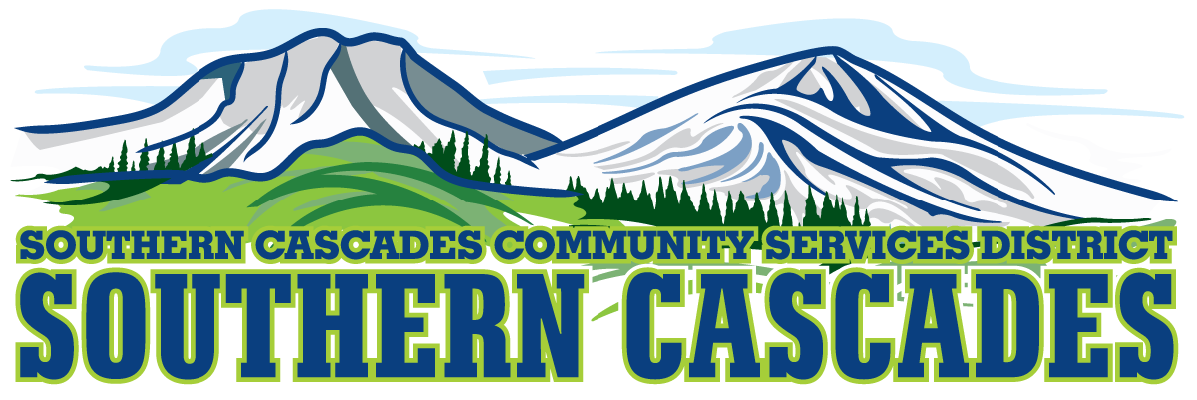

Conference Room
Southern Cascades Operations Base
Training and Conference Center
205 Ash Valley Road, Adin, CA 96006
August 10, 2018 5:30 pm
BOARD MEETING
AGENDA
- Call to Order

- Pledge of Allegiance

- Deletions/Additions and Approval of Agenda
4.0 Public Comment: This is the time set aside for citizens to address the Board on matters on the consent agenda and matters not otherwise on the agenda. Comments should be limited to matters within the jurisdiction of the Board. If your comment concerns an item shown on the agenda. Please address the Board after that item is open for public comment. By law, the Board cannot take action on matters that are not on the agenda. The chair reserves the right to limit the duration of each speaker to three minutes. The speaker may not cede their time.
Agenda items with times listed will be considered at that time. All other items will be considered as listed on the agenda or as deemed necessary by the Chairperson.

7.0 Approval of Minutes:
July 9, 2018 Regular Meeting

- Correspondence

- CFO Report

- Information / Discussion

  - None ?

- Consideration / Action

  - Approve delegation of Authority to District Manager to negotiate Services Contracts for a value under $50,000.

9.0 SEMSA Report
- District Manager Report

11.0 CLOSED SESSION Conference with legal Counsel- Initiation of Litigation Government Code Section 54956.9 Number of Cases 1
12.0 Board Reports
13.0 Adjournment

Parties with a disability as provided by the American Disabilities Act who require special accommodations or aides in order to participate in the public meeting should make the request by calling 530 299 3110 at least 48 hours prior to the meeting.

Posted at Southern Cascades Operations Base and Training Center Foyer and Adin Post Office Bulletin Board July 6, 2018.

