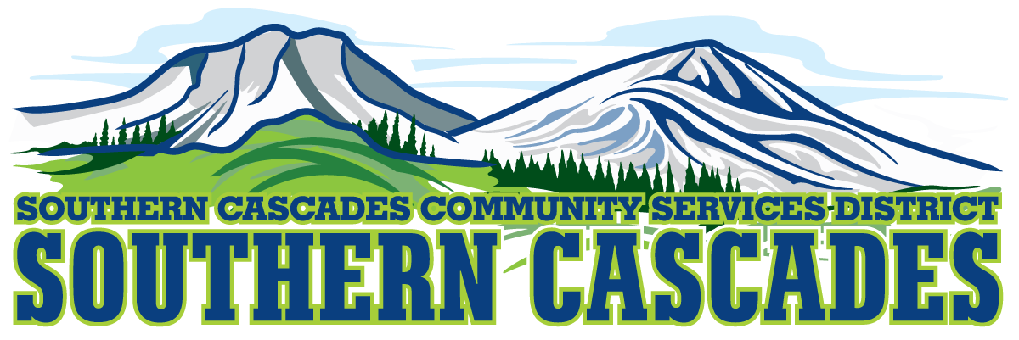
Conference Room
Southern Cascades Operations Base and Training Center
205 Ash Valley Road, Adin, CA 96006
January 17, 2022 5:30 pm
BOARD MEETING
AGENDA

- Call to Order

- Pledge of Allegiance

4.0 Roll Call and Establishment of a Quorum of the Board of Directors
5.0 Deletions /Additions and Approval of Agenda
6.0 Public Comment: This is the time set aside for citizens to address the Board on matters on the consent agenda and matters not otherwise on the agenda. Comments should be limited to matters within the jurisdiction of the Board. If your comment concerns an item shown on the agenda. Please address the Board after that item is open for public comment. By law, the Board cannot take action on matters that are not on the agenda. The chair reserves the right to limit the duration of each speaker to three minutes. The speaker may not cede their time.
Agenda items with times listed, will be considered at that time. All other items, will be considered as listed on the agenda or as deemed necessary by the Chairperson.

- Election of Board Officers for 2022

7.1 Board Chair
7.1.1 Nominations for Board Chair
7.1.2 Election of Board Chair
7.2 Board Vice Chair
7.2.1 Nominations for Board Vice Chair
7.2.2 Election of Board Vice Chair
7.3 Board Secretary
7.3.1 Nominations for Board Secretary
7.3.2 Election of Board Secretary
7.4 Board Treasurer
7.4.1 Nominations for Board Treasurer
7.4.2 Election of Board Treasurer
8.0 Consent Agenda
8.1 Approve Minutes for the following meeting;
Special Board Meeting January 4, 2022

- Consideration / Action

9.1 Consider and Approve to engage and open checking and money market accounts per the proposal dated 2022-01-13 at Five Star Bank.

9.2 Consider and Approval for the District General Administrator to initiate an application for 5310 Grant for procurement of a HTS vehicle for service in Lassen County.

9.3 Delegate authority to District General Administrator to 5310 Grant for operational funds for transport of non-medical patients to medical appointments and pharmacy visits in Lassen County.
9.4 Delegate authority to District General Administrator for authority to apply for 5310 Grant for procurement of an NEMT and NMT transport in Modoc County.

9.5 Delegate authority to District General Administrator to engage a Grant Writer for preparation of a USDA Public Assistance Grant for replacing HTS vehicles 6003 and 6880. This would be an in-kind replacement if the mini vans are available.

9.6 Accept receipt of N95 Mask Quantitative Fit Testing Equipment from Modoc County Health.

- Information / Discussion
10.1 Standing Committee Assignments
11.0 CFO Report
11.1 December Financials

12.0 Correspondence
13.0 District General Administrator Report
14.0 Board Reports

15.0 Closed Session
15.1 Per Government Code 54957, Public Employee Performance Evaluation District General Administrator.

16.0 Resume Open Session

17.0 Adjournment

Parties with a disability as provided by the American Disabilities Act who require special accommodations or aides in order to participate in the public meeting should make the request by calling 530 299 3110 at least 24 hours prior to the meeting.

Posted at Southern Cascades Operations Base and Training Center Foyer and Adin Post Office Bulletin Board and the SCCSD Web Site January 13, 2022.

