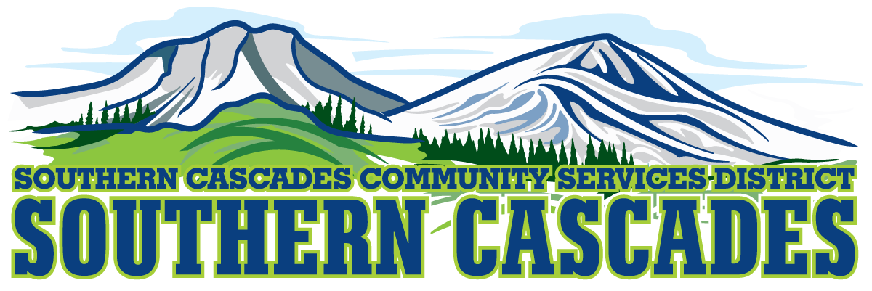
Conference Room
Southern Cascades Operations Base and Training Center
205 Ash Valley Road, Adin, CA 96006
November 21, 2022 5:30 pm
Regular Board Meeting

- Call to Order

- Pledge of Allegiance

3.0 Roll Call and Establishment of a Quorum of the Board of Directors
4.0 Deletions /Additions and Approval of Agenda
5.0 Public Comment: This is the time set aside for citizens to address the Board on matters on the consent agenda and matters not otherwise on the agenda. Comments should be limited to matters within the jurisdiction of the Board. If your comment concerns an item shown on the agenda. Please address the Board after that item is open for public comment. By law, the Board cannot take action on matters that are not on the agenda. The chair reserves the right to limit the duration of each speaker to three minutes. The speaker may not cede their time.
Agenda items with times listed, will be considered at that time. All other items, will be considered as listed on the agenda or as deemed necessary by the Chairperson.

6.0 Consent Agenda
6.1 Approve Minutes from the Regular Board Meeting October 17, 2022
6.2 Approve Minutes from the Special Board Meeting October 24, 2022

7.0 CFO/Finance Committee presents October 2022 Financials
7.1 Consideration/Action
Approve Finance Committee Report

8.0 Correspondence

9.0 Education Division Manager Report

10.0 EMS Division Manager Report

11.0 HTS Supervisor Report

12.0 Operations Analyst Report

13.0 Grants Manager Report

14.0 District General Administrator Report

15.0 CLOSED SESSION- Per Government Code 54936 (c), Emmert VS SCCSD, Case 9137

16.0 Resume OPEN SESSION

17.0 Consideration/Action
17.1 Approve Any Formal Action to be taken by board as result of closed session.

18.0 CLOSED SESSION Per Government Code 54957, Public Employment, District General Administrator

19.0 Resume OPEN SESSION

20.0 Consideration/Action
20.1 Approve Any Formal Action to be taken by board as result of closed session.

21.0 Adjournment
Parties with a disability as provided by the American Disabilities Act who require special accommodations or aides in order to participate in the public meeting should make the request by calling 530 299 3110 at least 24 hours prior to the meeting.

Posted at Southern Cascades Operations Base and Training Center Foyer and the SCCSD Web Site Friday November 18, 2022.

