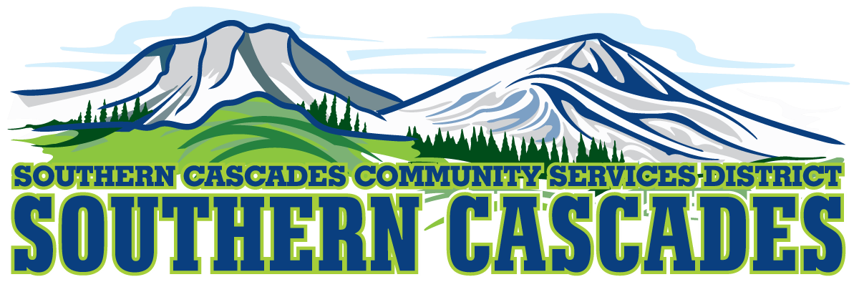

Conference Room
Southern Cascades Operations Base and Training Center
205 Ash Valley Road, Adin, CA 96006
January 4, 2022, 5:30 pm
Special Board Meeting
AGENDA
1.0 Call to Order

2.0 Pledge of Allegiance

3.0 Deletions/Additions and Approval of Agenda
4.0 Public Comment: This is the time set aside for citizens to address the Board on matters on the consent agenda and matters not otherwise on the agenda. Comments should be limited to matters within the jurisdiction of the Board. If your comment concerns an item shown on the agenda. Please address the Board after that item is open for public comment. By law, the Board cannot take action on matters that are not on the agenda. The chair reserves the right to limit the duration of each speaker to three minutes. The speaker may not cede their time.
Agenda items with times listed, will be considered at that time. All other items, will be considered as listed on the agenda or as deemed necessary by the Chairperson.

5.0 Consent Agenda
5.1 Approve Minutes for the following Meeting:
Regular Meeting-November 15, 2021

6.0 Consideration / Action

6.1 Approve the proposed EMS write off for bad debt.
6.2 Approve the Appeal of the taxation of 4 parcels taxed in Lassen County for the Parks Family Revocable Trust 1995 and refund the Trust $130.00 for the 2021-2022 Tax year.
6.3 Approve the increase of Emergency Medical Technician (Per Diem) to $17.64 per hour.

7.0 Information / Discussion

8.0 CFO Report

9.0 Correspondence

10.0 District General Administrator Report

11.0 Board Reports

12.0 Closed Session
12.1 Per Government Code 54957, Public Employee Performance Evaluation District General Administrator.

13.0 Resume Open Session

14.0 Consideration/Action
14.1 Approve Any Formal Action to be taken by board as result of closed session.

15.0 Adjournment

Parties with a disability as provided by the American Disabilities Act who require special accommodations or aides in order to participate in the public meeting should make the request by calling 530 299 3110 at least 24 hours prior to the meeting.

Posted at Southern Cascades Operations Base and Training Center Foyer and the SCCSD Web Site December 31, 2021.

