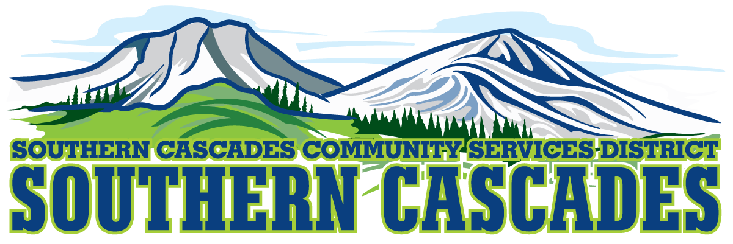
205 Ash Valley Rd. PO Box 239, Adin, CA 96006
www.southerncascades.org
VACANCY ANNOUNCEMENT
PART TIME POSITION
HEALTH TRANSPORT TECHNICIAN
POSITION AVAILABLE
ADIN/BIGVALLEY AREA
SUCCESSFUL APPLICANTS MUST:
HAVE A CLEAN CLASS C CALIFORNIA LIC. AND BE 21 YEARS OLD
PASS TRAINING PROVIDED BY EMPLOYER
PASS CRIMINAL BACKGROUND CHECK SUCCESSFULLY PASS DRUG SCREENING
FOR APPLICATIONS OR INFORMATION
CALL 530 299-3110
SOUTHERN CASCADES CSD IS AN EQUAL OPPORTUNITY EMPLOYER AND SERVICE PROVIDER

