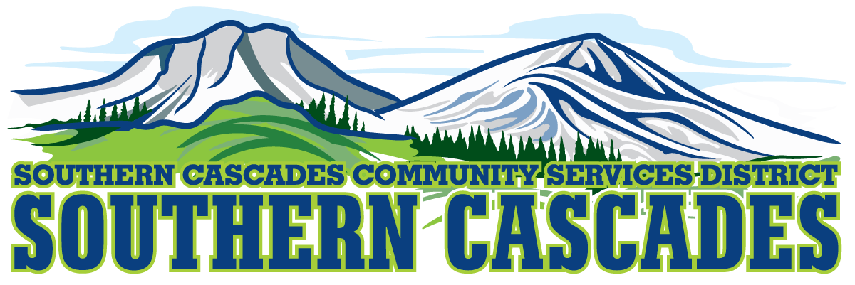
Conference Room
Southern Cascades Operations Base and Training Center
205 Ash Valley Road, Adin, CA 96006
December 19, 2022 5:30 PM
Regular Board Meeting Agenda

- Call to Order

- Pledge of Allegiance

- Swearing in of three Board Members and Swearing in of Karli Dowell

4.0 Roll Call and Establishment of a Quorum of the Board of Directors
5.0 Deletions /Additions and Approval of Agenda
6.0 Public Comment: This is the time set aside for citizens to address the Board on matters on the consent agenda and matters not otherwise on the agenda. Comments should be limited to matters within the jurisdiction of the Board. If your comment concerns an item shown on the agenda. Please address the Board after that item is open for public comment. By law, the Board cannot take action on matters that are not on the agenda. The chair reserves the right to limit the duration of each speaker to three minutes. The speaker may not cede their time.
Agenda items with times listed, will be considered at that time. All other items, will be considered as listed on the agenda or as deemed necessary by the Chairperson.

7.0 Consent Agenda
7.1 Approve Budget Amendments for increasing the minimum wage effective 1/1/2023.
Positions this effects Health Transport Technicians $15.50 and Logistics Technician $15.50

8.0 Consideration/Action
8.1 Approve Budget Amendment for fee of $2000.00 to Modoc County Sheriff’s Department for EMS Dispatch
8.2 Approve District Policy regarding Storage of District Vehicles at employee’s homes
8.3 Approve the Delegation of Authority for Karli Dowell to complete background checks for employees, to have account access to Five Star Bank and Tri County Bank, Drug and Alcohol testing for employees, “DER”, Five Star Bank Credit Card with authorized use for up to $30,000.
9.0 CFO Report
9.1 Finance Committee Report
10.0 HTS Supervisor Report
11.0 EMS Division Manager Report
12.0 Education Division Manger Report
13.0 District Analyst Report
14.0 District Grants Manager Report
15.0 District General Administrator Report
16.0 Board Reports
17.0 CLOSED SESSION Per Government Code 54957, Public Employment, District General Administrator Evaluation Performance
18.0 Resume OPEN SESSION
19.0 Approve any formal action to be taken by board as result of closed session
Approve Contract for District General Administrator
20.0 Adjournment

Parties with a disability as provided by the American Disabilities Act who require special accommodations or aides in order to participate in the public meeting should make the request by calling 530 299 3110 at least 24 hours prior to the meeting.

Posted at Southern Cascades Operations Base and Training Center Foyer and the SCCSD Web Site Friday December 16, 2022

