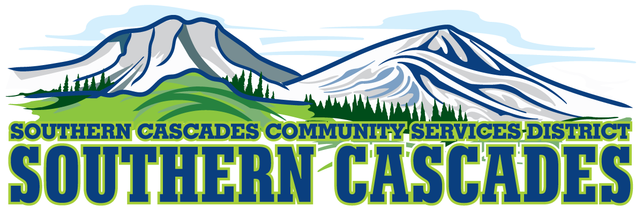
Conference Room
Southern Cascades Operations Base and Training Center
205 Ash Valley Road, Adin, CA 96006
February 19, 2024 5: 00 PM
Regular Board Meeting Agenda

- Call to Order

- Pledge of Allegiance

3.0 Roll Call and Establishment of a Quorum of the Board of Directors
4.0 Deletions /Additions and Approval of Agenda
5.0 Public Comment: This is the time set aside for citizens to address the Board on matters on the consent agenda and matters not otherwise on the agenda. Comments should be limited to matters within the jurisdiction of the Board. If your comment concerns an item shown on the agenda. Please address the Board after that item is open for public comment. By law, the Board cannot take action on matters that are not on the agenda. The chair reserves the right to limit the duration of each speaker to three minutes. The speaker may not cede their time.
Agenda items with times listed, will be considered at that time. All other items, will be considered as listed on the agenda or as deemed necessary by the Chairperson.

6.0 CLOSED SESSION-
6.1 Per Government Code § 54957, Public Employee Performance Evaluation- District General Administrator
6.2 Per Government Code § 551.071, Real Property Negotiations
6.3 Per Government Code § 54956.9 (d) Conference with Legal Counsel-Anticipated Litigation, Significant Exposure to Litigation-one potential case

7.0 Reconvene to Open Session
7.1 Instruction is given to staff, resultant of the Closed Session

8.0 Reports
8.1 Finance Committee Report
8.2 CFO Report
8.3 District General Administrator Report
9.0 Consent Agenda
9.1 Approve placement of all board-approved policies under Southern Cascades Community Services District Policy & Procedure Handbook
9.2 Approve District General Administrator to attend the SDRMA Spring Education Day: March 25-26. (Registration is free; hotel is $149.00 plus tax for one night
9.3 Approve the District General Administrator to attend CSDA Budget Preparation for Special Districts Virtual Workshop: February 28-29 Cost is $230.00 for CSDA members
9.4 Approve District General Administrator to attend Northstate Prehospital Conference: April 20 at the Win River Casino, Redding. Cost is $82.00 to attend
9.5 Approve District General Administrator to attend State of Jefferson EMS Conference: March 7-8 in Ashland Oregon. Registration is $180.00; hotel is $253.00 per night for two nights.
9.6 Approve revisions to Policy #6203.0 Probationary Period, changing the probationary period from 6 months to 90 days.
9.7 Approve Resolution 2024-01 to finance 2 Suburu Crosstreks financed by Stefan Morton.

10.0 Action Items
10.1 Accept the January 2024 Financials

11.0 Discussion
11.1 Establish a Policy Committee meeting date
11.2 Discuss Southern Cascades Community Services District providing contract Grant Writing services and rates associated with service
12.0 Correspondence
Letter received regarding Southern Cascades Community Services District AB716 Compliant Hardship Policy

13.0 Adjournment

Parties with a disability as provided by the American Disabilities Act who require special accommodations or aides in order to participate in the public meeting should make the request by calling 530 299 3110 at least 24 hours prior to the meeting.
Posted at Southern Cascades Operations Base and Training Center Foyer and the SCCSD Web Site February 16, 2024.

