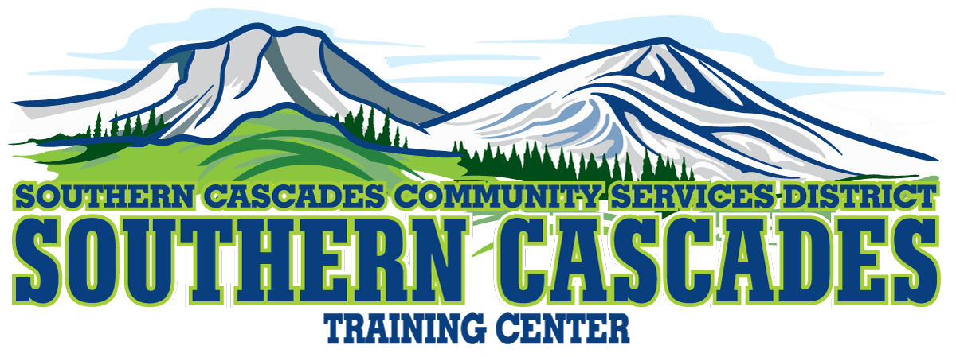
205 Ash Valley Road, Adin CA 96006
Mailing: P.O. Box 239 Adin CA 96006
Phone (530) 299-3110
EMT CLASS, Spring 2023
What does class cover?
The course curriculum covers all EMT knowledge and skill requirements for the EMT National Education Standards (NES).
If you are a self-motivated, goal-oriented student who enjoys being challenged, this is a great educational opportunity that will aid in your goal of an NREMT, EMT Certification.
Upon successful completion of this EMT basic course a student will be authorized to take the National Registry of Emergency Medical Technicians (NREMT) practical skills and cognitive examinations. After passing the examinations the student will be awarded NREMT EMT Certification. These certification exams are used as a basis for the state licensure of certification in most states.
Where will classes be located?
Classes will be a combination of online live zoom classes and in-person at Southern Cascades Training Center in Adin.
When is the class?
Start date to be announced.
For application form and further information please: call (530) 299-3110 or
Email edudivisionmanager@southerncascades.org

