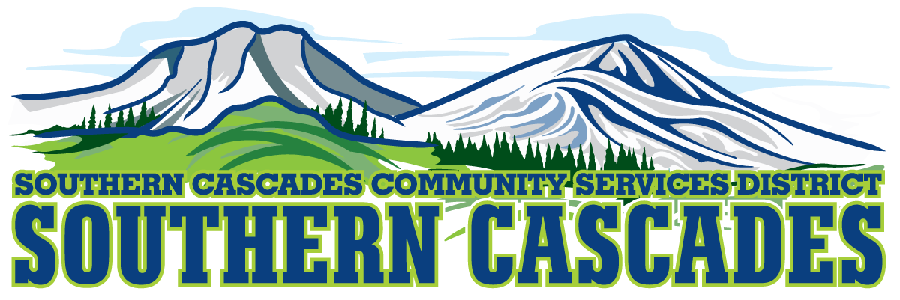

Conference Room
Southern Cascades Operations Base
Training and Conference Center
205 Ash Valley Road, Adin, CA 96006
June 10, 2019 5:30 pm
BOARD MEETING
AGENDA
- Call to Order

- Pledge of Allegiance

- Moment of Silence and Request for Adjournment in Memory of EMT Emily Griffin

- Deletions/Additions and Approval of Agenda
5.0 Public Comment: This is the time set aside for citizens to address the Board on matters on the consent agenda and matters not otherwise on the agenda. Comments should be limited to matters within the jurisdiction of the Board. If your comment concerns an item shown on the agenda. Please address the Board after that item is open for public comment. By law, the Board cannot take action on matters that are not on the agenda. The chair reserves the right to limit the duration of each speaker to three minutes. The speaker may not cede their time.
Agenda items with times listed will be considered at that time. All other items will be considered as listed on the agenda or as deemed necessary by the Chairperson.
6.0 Correspondence

7.0 CFO Report
May, 2019 Financials

8.0 Consideration / Action
8.1 Approve District Manager to sign agreement for Purchase Card with
Tri Counties Bank. Delegated Authorities will be the Following:
Delegated Purchasing Authorities:
Position Per Purchase Per Month
District Manager $ 5,000 $10,000
Program Managers $ 1,000 $5,000
Operations Supervisors $ 500 $1,000

8.2 Authorize Board Chair Clinton Davis authority to bind the district legally and financially to the laws, regulations and program instructions of Medicare.
8.3. Approve CFO and District Manager recommendation to adopt biweekly pay periods beginning July 1, 2019.
8.4 Approve staff recommendation to use SDRMA for providing Health Insurance Coverage to our full time Employees. Coverage Options offered would have a two level option with the Gold Plan and Platinum Plan.
The District would pay 75 percent for the Employee and 50 percent for dependents of cost of Gold Plan. The employee would pay the additional cost of the Platinum Plan if they elected the Platinum Plan.
For the purposes of Health Care Coverage Employees with an average of 30 or more hours worked per week would be considered full time.
8.5 Authorize Board Chair to attend California Special District Leadership Academy July 7-10 in Napa, California. Scholarship will be applied for to reimburse the District for Tuition Expenses.
8.6 Approve Tentative 2019-2020 Budget.

9.0 Information / Discussion
9.1 Briefing on Lassen EMCC Meeting on June 4.

10.0 SEMSA Report

11.0 District Manager Report

12.0 CLOSED SESSION
Conference with Legal Counsel- Initiation of Litigation
Government Code Section 54956.9 Number of Cases 1

Return to Open Session: Report of Closed Session

13.0 Board Reports

14.0 Adjournment in Memory of Emily Griffin

Parties with a disability as provided by the American Disabilities Act who require special accommodations or aides in order to participate in the public meeting should make the request by calling 530 299 3110 at least 48 hours prior to the meeting.

Posted at Southern Cascades Web Site, Operations Base and Training Center Foyer and Adin Post Office Bulletin Board June 7, 2019.

