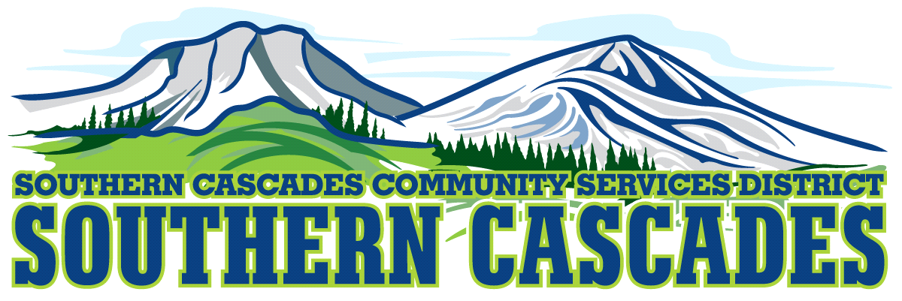
Conference Room
Southern Cascades Operations Base and Training Center
205 Ash Valley Road, Adin, CA 96006
May 20, 2024, 5: 00 PM
Regular Board Meeting Agenda

1.0 Call to Order
2.0 Pledge of Allegiance
3.0 Roll Call and Establishment of a Quorum of the Board of Directors
4.0 Deletions / Additions and Approval of Agenda
5.0 Public Comment: This is the time set aside for citizens to address the Board on matters on the consent agenda and matters not otherwise on the agenda. Comments should be limited to matters within the jurisdiction of the Board. If your comment concerns an item shown on the agenda. Please address the Board after that item is open for public comment. By law, the Board cannot take action on matters that are not on the agenda. The chair reserves the right to limit the duration of each speaker to three minutes. The speaker may not cede their time.
Agenda items with times listed, will be considered at that time. All other items will be considered as listed on the agenda or as deemed necessary by the Chairperson.

6.0 Closed Session
6.1 Per Government Code § 54957, Public Employee Performance Evaluation- District General Administrator
6.2 Per Government Code § 551.071, Real Property Negotiations
6.3 Per Government Code § 54956.9 (d) Conference with Legal Counsel-Anticipated Litigation, Significant Exposure to Litigation-(2) potential cases

7.0 Reconvene to Open Session
7.1 Instruction is given to staff, resultant of Closed Session
8.0 Reports
8.1 SingletonAumen PC presents the Fiscal Year End Audits 2019 & 2020
8.2 Finance Committee Report
8.3 CFO Report
8.4 District General Administrator Report
8.5 EMS Manager Report
8.6 Education Manager Report
9.0 Action Items
9.1 Approve the minutes for April 15, 2024, board meeting
9.2 Approve amendments to Evaluation Policy #6207.0, changing name to Performance & Salary Review and revising policy language
9.3 Approve At Will Employment Policy
9.4 Approve FMLA Policy
9.5 Approve Make Up Time Policy
9.6 Approve Stipend Policy
9.7 Approve Timekeeping Policy
9.8 Approve Whistleblower Policy
9.9 Approve Employee Handbook
9.10 Approval to surplus (2) Southern Cascades Community Services District power gurneys
9.11 Accept the Fiscal Year End Audits 2019 & 2020, as presented by SingletonAuman PC
9.12 Accept April Financials

10.0 Adjournment

Parties with a disability as provided by the American Disabilities Act who require special accommodations or aides in order to participate in the public meeting should make the request by calling 530 299 3110 at least 24 hours prior to the meeting.
Posted at Southern Cascades Operations Base and Training Center Foyer and the SCCSD Web Site May 17 , 2024.

