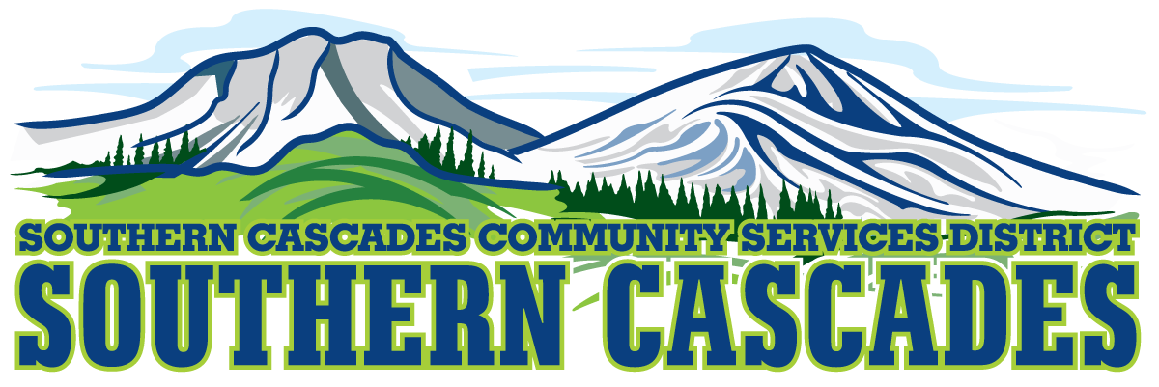

Conference Room
Southern Cascades Operations Base and Training Center
205 Ash Valley Road, Adin, CA 96006
June 11, 2018 5:30 pm
BOARD MEETING
AGENDA
- Call to Order

- Pledge of Allegiance

- Deletions/Additions and Approval of Agenda
4.0 Public Comment: This is the time set aside for citizens to address the Board on matters on the consent agenda and matters not otherwise on the agenda. Comments should be limited to matters within the jurisdiction of the Board. If your comment concerns an item shown on the agenda. Please address the Board after that item is open for public comment. By law, the Board cannot take action on matters that are not on the agenda. The chair reserves the right to limit the duration of each speaker to three minutes. The speaker may not cede their time.
Agenda items with times listed will be considered at that time. All other items will be considered as listed on the agenda or as deemed necessary by the Chairperson.

7.0 Approval of Minutes:
May 14 Regular Meeting

- Correspondence

- CFO Report

- Information / Discussion

  - Training Center
7.2 NMT-NEMT Start UP

- Consideration / Action
8.1 Approve Delegation of Authority to District Manager to execute and sign contract with Medical Transport Management, Inc. at the negotiated rates.
8.2 Approve Delegation for Signature of Checks for the Southern Cascades Tri Counties Checking Account. Designate signing authority for Valerie Endicott, Dan Bouse and Bob Fisher.

8.3 Approve Delegation to establish a Savings Account at Tri Counties Bank with an initial Transfer of $50,000 from District Checking account.

8.4 Elect Vice Chair for remainder of Calendar Year 2018

8.5 Approve Delegation of Authority to begin hiring process for NMT-NEMT Program.

8.6 Approve establishing the Capitalization Policy being as $1000.00
and above for Capitalization and Depreciation.

9.0 Chair Person Appointments:
Committee Assignments vacated by Jean Ludwigsen resignation.

10.0 SEMSA Report
- District Manager Report
11.0 Board Reports
12.0 Adjournment

Parties with a disability as provided by the American Disabilities Act who require special accommodations or aides in order to participate in the public meeting should make the request by calling 530 299 3110 at least 48 hours prior to the meeting.

Posted at Southern Cascades Operations Base and Training Center Foyer and Adin Post Office Bulletin Board June 8, 2018.

