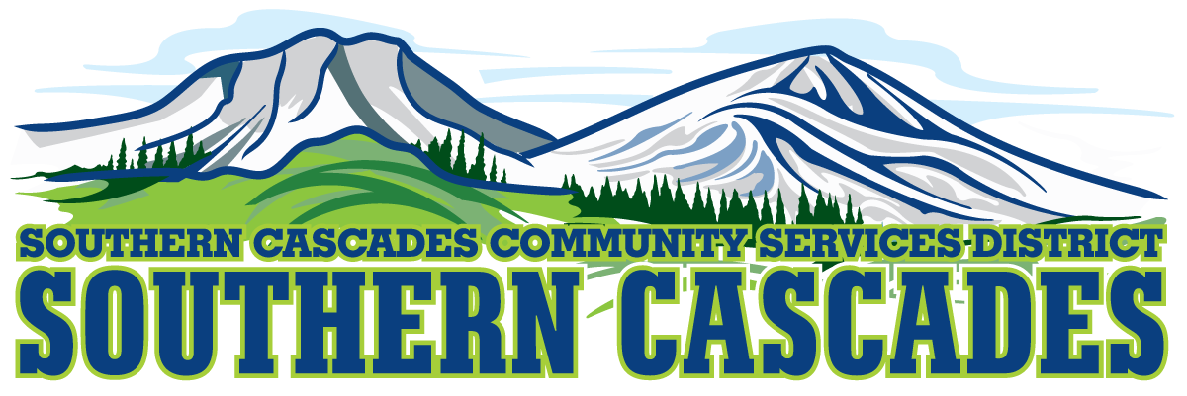

Conference Room
Southern Cascades Operations Base
Training and Conference Center
205 Ash Valley Road, Adin, CA 96006
May 13, 2019 5:30 pm
BOARD MEETING
AGENDA
- Call to Order

- Pledge of Allegiance

- Deletions/Additions and Approval of Agenda
4.0 Public Comment: This is the time set aside for citizens to address the Board on matters on the consent agenda and matters not otherwise on the agenda. Comments should be limited to matters within the jurisdiction of the Board. If your comment concerns an item shown on the agenda. Please address the Board after that item is open for public comment. By law, the Board cannot take action on matters that are not on the agenda. The chair reserves the right to limit the duration of each speaker to three minutes. The speaker may not cede their time.
Agenda items with times listed will be considered at that time. All other items will be considered as listed on the agenda or as deemed necessary by the Chairperson.
5.0 Correspondence

6.0 CFO Report
March 2019 Financials

7.0 Consideration / Action
7.1 Approve District Participation in the Lassen Modoc Adult Education Consortium 2019-20 Mini Grant Application.
7.2 Authorize District Manager to establish position for EMS Program Manager, Advertise and Hire.
7.3. Authorize District Manager to establish position of Administrative Assistant/Dispatcher Position, Advertise and Hire.
7.3 Authorize District Manager to begin negotiation for hiring Medical Director for Southern Cascades CSD.
7.4 Authorize District Manager to begin Negotiations with Modoc County Health Services for Transportation Services.

8.0 Information / Discussion
NONE

9.0 SEMSA Report

10.0 District Manager Report

11.0 CLOSED SESSION
Conference with Legal Counsel- Initiation of Litigation
Government Code Section 54956.9 Number of Cases 1

Return to Open Session: Report of Closed Session

12.0 Board Reports

13.0 Adjournment

Parties with a disability as provided by the American Disabilities Act who require special accommodations or aides in order to participate in the public meeting should make the request by calling 530 299 3110 at least 48 hours prior to the meeting.

Posted at Southern Cascades Web Site, Operations Base and Training Center Foyer and Adin Post Office Bulletin Board May 10, 2019.

