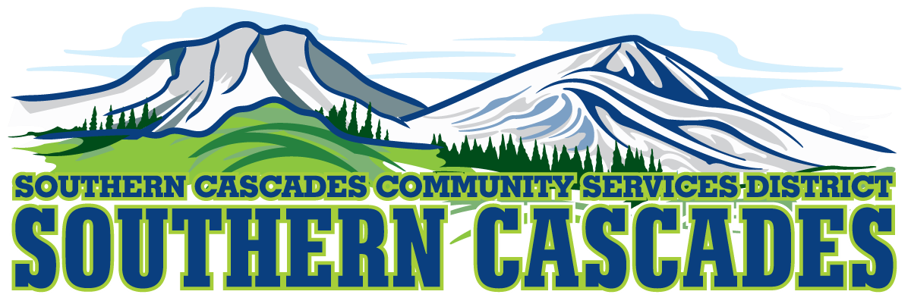
530-299-3110 205 Ash Valley Rd. PO Box 239, Adin, CA 96006
www.southerncascades.org
PUBLIC NOTICE
NOTICE OF BUDGET HEARING
SOUTHERN CASCADES COMMUNITY SERVICE DISTRICT

A PUBLIC HEARING will be held on August 21, 2023 commencing at 5:30 p.m. at the Southern Cascades Community Service District Conference Room, located at 205 Ash Valley Rd., Adin, California, and continuing from day to day thereafter except for Saturdays, Sundays and holidays, at the same place, until completed, regarding establishment of the Southern Cascades Community Service District final budget for Fiscal Year 2023/2024. Any member of the general public may appear at the hearing and be heard regarding any item of the budget or for the inclusion of additional items.
Proposed budget documents are available commencing August
18, 2023 in the District Operations Office located at 205 Ash Valley Rd., Adin, California.

/s/ Karli Frye
Karli Frye, District General Administrator
Southern Cascades Community Service District

