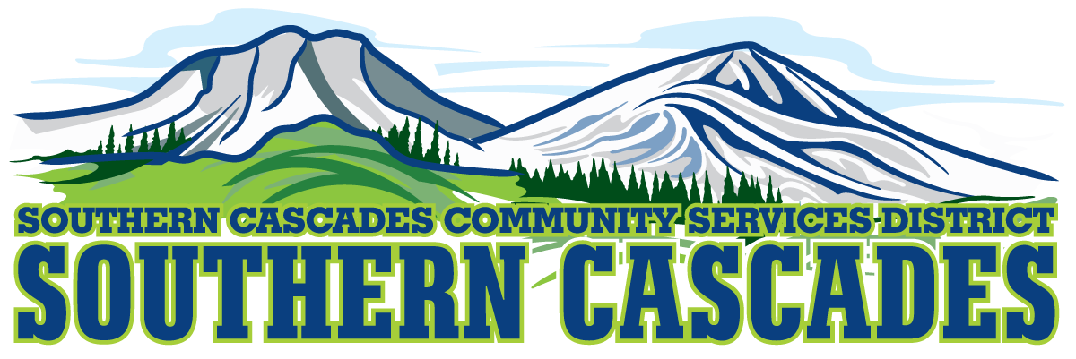
Conference Room
Southern Cascades Operations Base and Training Center
205 Ash Valley Road, Adin, CA 96006
October 24, 2022 6:00 pm
Special Board Meeting
AGENDA

- Call to Order

- Pledge of Allegiance

3.0 Roll Call and Establishment of a Quorum of the Board of Directors
4.0 Deletions /Additions and Approval of Agenda
5.0 Public Comment: This is the time set aside for citizens to address the Board on matters on the consent agenda and matters not otherwise on the agenda. Comments should be limited to matters within the jurisdiction of the Board. If your comment concerns an item shown on the agenda. Please address the Board after that item is open for public comment. By law, the Board cannot take action on matters that are not on the agenda. The chair reserves the right to limit the duration of each speaker to three minutes. The speaker may not cede their time.
Agenda items with times listed, will be considered at that time. All other items, will be considered as listed on the agenda or as deemed necessary by the Chairperson.

6.0 Consideration/Action
6.1 Approve $60,000 bridge loan, due February 15, 2023

7.0 CLOSED SESSION
7.1 Per Government Code 54936 (c), Conference with Legal Counsel regarding Litigation, (1) Case

8.0 Resume Open Session

9.0 Consideration/Action
9.1 Approve Any Formal Action to be taken by board as result of closed session.

10.0 Adjournment

Parties with a disability as provided by the American Disabilities Act who require special accommodations or aides in order to participate in the public meeting should make the request by calling 530 299 3110 at least 24 hours prior to the meeting.

Posted at Southern Cascades Operations Base and Training Center Foyer and the SCCSD Web Site Friday October 21, 2022.

