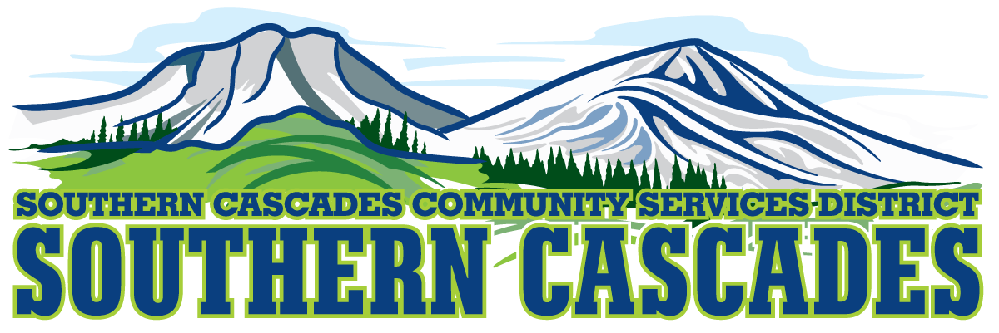
Conference Room
Southern Cascades Operations Base
205 Ash Valley Road, Adin, CA 96006
September 7, 2023 5:00 PM
Special Board Meeting

- Call to Order

- Pledge of Allegiance

3.0 Roll Call and Establishment of a Quorum of the Board of Directors
4.0 Deletions /Additions and Approval of Agenda
5.0 Discussion
5.1 Purchase of the two Subaru’s for HTS regarding credit application and needing a “Guarantor” to run credit on behalf of the District
6.0 CLOSED SESSION
6.1 Per Government Code 54957, Public Employee Performance Evaluation- District General Administrator
6.2 Per Gov’t Code § 551.071. Real Property Deliberations
7.0 Resume Open Session
8.0 Consideration/Action
8.1 Instruction given to staff as a result of the Closed Session.
9.0 Adjournment

Parties with a disability as provided by the American Disabilities Act who require special accommodations or aides in order to participate in the public meeting should make the request by calling 530 299 3110 at least 24 hours prior to the meeting.
Posted at Southern Cascades Operations Base and Training Center Foyer and the SCCSD Web Site Friday September 1, 2023.

