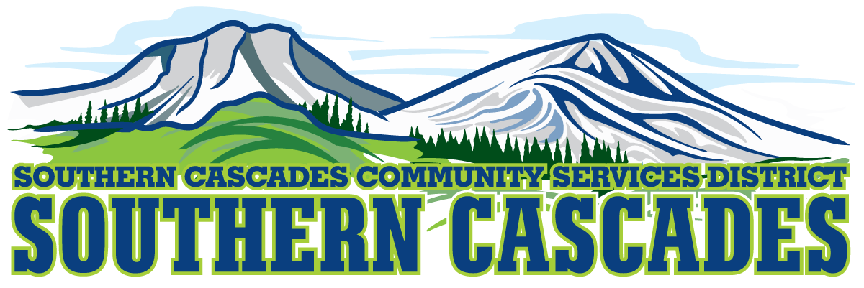
Conference Room
Southern Cascades Operations Base and Training Center
205 Ash Valley Road, Adin, CA 96006
December 19, 2022 4:00 PM
Finance Committee Meeting

- Call to Order

- Consideration/Action
  - Review and Recommend Approval of November 2022 Financials
  - Mapping of Receivables for EMS

- Report and Discussion
3.1 District Business Analyst Fiscal mapping analysis findings

4.0 Adjournment

Parties with a disability as provided by the American Disabilities Act who require special accommodations or aides in order to participate in the public meeting should make the request by calling 530 299 3110 at least 24 hours prior to the meeting.

Posted at Southern Cascades Operations Base and Training Center Foyer and the SCCSD Web Site Friday December 16, 2022

