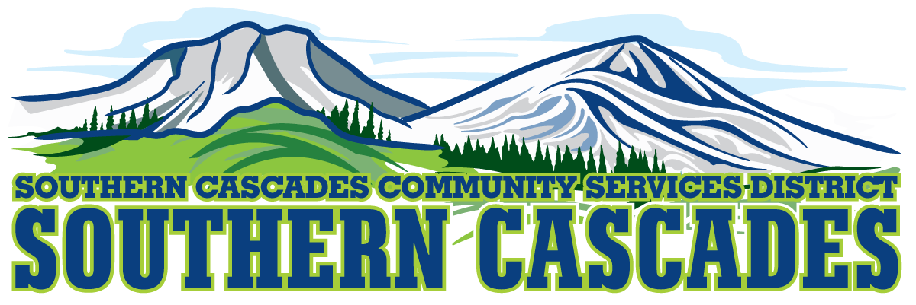

Conference Room

Southern Cascades Operations Base and Training Center

205 Ash Valley Road, Adin, CA 96006

**July 15, 2024 5: 00 PM**

**Regular Board Meeting Agenda**

1. **Call to Order**

1. **Pledge of Allegiance**

**3.0 Roll Call and Establishment of a Quorum of the Board of Directors**

**4.0 Deletions /Additions and Approval of Agenda**

**5.0 Public Comment:** *This is the time set aside for citizens to address the Board on matters on the consent agenda and matters not otherwise on the agenda. Comments should be limited to matters within the jurisdiction of the Board. If your comment concerns an item shown on the agenda. Please address the Board after that item is open for public comment. By law, the Board cannot take action on matters that are not on the agenda. The chair reserves the right to limit the duration of each speaker to three minutes. The speaker may not cede their time.*

*Agenda items with times listed, will be considered at that time. All other items, will be considered as listed on the agenda or as deemed necessary by the Chairperson.*

**6.0 CLOSED SESSION-**

6.1 Per Government Code § 54957, Public Employee Performance Evaluation- District General Administrator

6.2 Per Government Code § 551.071, Real Property Negotiations

6.3 Per Government Code § 54956.9 (d) Conference with Legal Counsel-Anticipated Litigation, Significant Exposure to Litigation-(2) potential cases

**7.0 Reconvene to Open Session**

7.1 Instruction is given to staff as a result of Closed Session

**8.0 Reports**

8.1 CFO Report

8.2 Finance Committee Report

8.3 Education Division Manager Report

8.4 EMS Division Manager Report

8.5 District General Administrator Report

**9.0 Consent Agenda**

* 1. Approve Regular Board Meeting minutes for June 17, 2024
  2. Approve the Fiscal year 2024-2025 Budget

**10.0 Consideration/ Action**

10.1 Approve **Resolution 2024-04** for 2024-2025 Tax Roll for Lassen County

10.2 Approve **Resolution 2024-05** for 2024-2025 Tax Roll for Modoc County

10.3 Approve Prop 218 Certification for Modoc County for Tax Year 2024-2025

10.4 Approve Prop 218 Certification for Lassen County for Tax Year 2024- 2025

10.5 Consider and approve District General Administrator applying for financing through Lithia Reno Suburu to purchase (1) or (2) Suburu Crosstreks

10.6 Approve District Surveillance Policy

**11.0 Adjournment**

**Parties with a disability as provided by the American Disabilities Act who require special accommodations or aides in order to participate in the public meeting should make the request by calling (530) 299- 3110 at least 24 hours prior to the meeting.**

**Posted at Southern Cascades Operations Base and Training Center Foyer and the SCCSD Web Site July 12, 2024.**