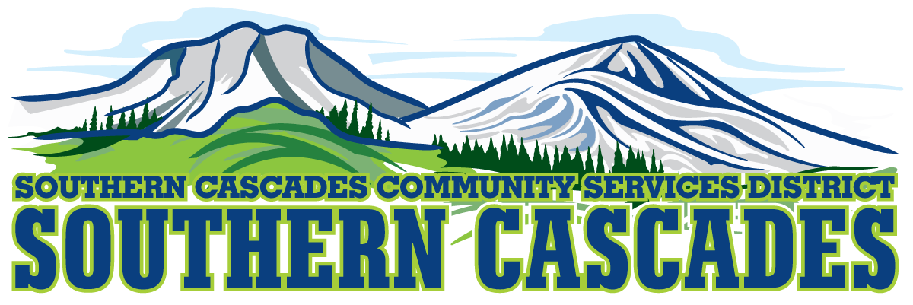
Southern Cascades Operations Base and Training Center
205 Ash Valley Road, Adin, CA 96006
February 20, 2023 5:30 pm
Regular Board Meeting
AGENDA

- Call to Order

- Pledge of Allegiance

3.0 Roll Call and Establishment of a Quorum of the Board of Directors
4.0 Deletions /Additions and Approval of Agenda
5.0 Public Comment: This is the time set aside for citizens to address the Board on matters on the consent agenda and matters not otherwise on the agenda. Comments should be limited to matters within the jurisdiction of the Board. If your comment concerns an item shown on the agenda. Please address the Board after that item is open for public comment. By law, the Board cannot take action on matters that are not on the agenda. The chair reserves the right to limit the duration of each speaker to three minutes. The speaker may not cede their time.
Agenda items with times listed, will be considered at that time. All other items, will be considered as listed on the agenda or as deemed necessary by the Chairperson.

6.0 Election of Board Officers for 2023

6.1 Board Chair
6.1.1 Nominations for Board Chair
6.1.2 Election of Board Chair
6.2 Board Vice Chair
6.2.1 Nominations for Board Vice Chair
6.2.2 Election of Board Vice Chair
6.3 Board Secretary
6.3.1 Nominations for Board Secretary
6.3.2 Election of Board Secretary
6.4 Board Treasurer
6.4.1 Nominations for Board Treasurer
6.4.2 Election of Board Treasurer
7.0 Consent Agenda
7.1 Approve Minutes for the following meeting;
Regular Board Meeting January 16, 2023

8.0 Information / Discussion
8.1 Standing Committee Assignments

8.2 Parcel fee reimbursement guidelines

8.3 Mayers Memorial Hospital and Southern Cascades CSD Cost Based Model

8.4 Establish date for Special Board Meeting to discuss and approve SCCSD seeking funding for the purchase of (2) Ford Transit Connects for the Health Transportation Division through the United States Department of Agriculture (USDA) Rural Development Community Facilities Grant
9.0 Action Items
9.1 Approval of District General Administrator attending SDRMA Spring Education Day Tuesday March 21st-Wednesday March 22nd, 2023. (Training is free, Hotel Room one night $139.00 plus tax)
9.2 Approval of District General Administrator attending CSDA General Leadership Summit, Sunday June 25th0Tuesday June 27th, 2023. (Training is $675.00 for CSDA member, Hotel Room 3 nights $199.00 plus tax and $15.00 hotel fee)

10.0 Reports/Actions:
10.1 Finance Committee Report
10.2 CFO Report
10.3 Education Division Manager Report
10.4 HTS Supervisor Report
10.5 EMS Division Manager Report
10.6 District General Administrator Report
10.7 Board Reports
11.0 Correspondence

12.0 Adjournment

Parties with a disability as provided by the American Disabilities Act who require special accommodations or aides in order to participate in the public meeting should make the request by calling 530 299 3110 at least 24 hours prior to the meeting.

Posted at Southern Cascades Operations Base and Training Center Foyer and Adin Post Office Bulletin Board and the SCCSD Web Site February 17, 2023.

