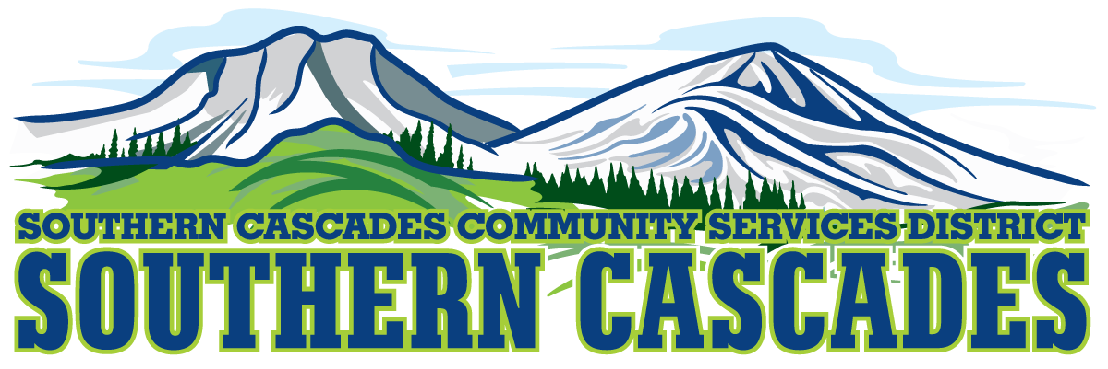
Southern Cascades EMS Campus, Board Room
205 Ash Valley Road, Adin, CA 96006

Finance Committee Meeting
Agenda for December 18, 2023
4:00 PM
1.0 Call to Order
2.0 Pledge of Allegiance
3.0 Approval or Additions/Deletions to Agenda
4.0 Public Comment: This is the time set aside for citizens to address the Board on matters on the consent agenda and matters not otherwise on the agenda. Comments should be limited to matters within the jurisdiction of the Board. If your comment concerns an item shown on the agenda, please address, the Board after that item is open for public comment. By law, the Board cannot take action on matters that are not on the agenda. The chair reserves the right to limit the duration of each speaker to three minutes. The speaker may not cede their time. Agenda items with times listed will be considered at that time. All other items will be considered as listed on the agenda or as deemed necessary by the Chairperson.
5.0 Discussion
5.1 November 2023 Financials
5.2 Vehicle Depreciation

6.0 Adjournment
Parties with a disability as provided by the American Disabilities Act who require special accommodations or aides in order to participate in the public meeting should make the request by calling 530-299-3110 at least 24 hours prior to the meeting. Parties requesting Board Packet should make that request by calling 530-299-3110. You may also contact the district manager by email at manager@southerncascades.org
Posted at Southern Cascades Operations Base and Training Center Foyer and the SCCSD Web Site Friday December 15, 2023.

