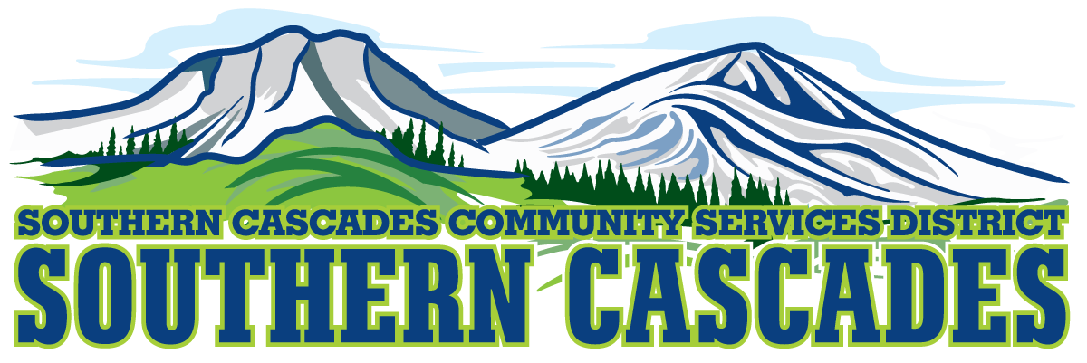
Conference Room
Southern Cascades Operations Base and Training Center
205 Ash Valley Road, Adin, CA 96006
February 21, 2022 5:30 pm
BOARD MEETING
AGENDA

- Call to Order

- Pledge of Allegiance

3.0 Roll Call and Establishment of a Quorum of the Board of Directors
4.0 Deletions /Additions and Approval of Agenda
5.0 Public Comment: This is the time set aside for citizens to address the Board on matters on the consent agenda and matters not otherwise on the agenda. Comments should be limited to matters within the jurisdiction of the Board. If your comment concerns an item shown on the agenda. Please address the Board after that item is open for public comment. By law, the Board cannot take action on matters that are not on the agenda. The chair reserves the right to limit the duration of each speaker to three minutes. The speaker may not cede their time.
Agenda items with times listed, will be considered at that time. All other items, will be considered as listed on the agenda or as deemed necessary by the Chairperson.

6.0 Consent Agenda
6.1 Approve Minutes for the following meeting;
Regular Board Meeting January 17, 2022
6.2 Increase Purchase Card Limit from $2000. To $3000. /month for Logistics Specialist

7.0 Information and Discussion:
7.1 FTA 5310 Grant Application

8.0 PUBLIC HEARING: FTA 5310 Grant at 5:45 P.M.

9.0 CLOSE PUBLIC HEARING

10.0 Consideration/Action
10.1 Certify that no non- profit or association is interested in applying in Lassen County for the 5310 Grant; therefore, the Board will pass resolution to apply for the 5310 Grant.

11.0 Information and Discussion:
11.1 Planning for the possible replacement of our Medical Director, Dr. Dahle upon his retirement.

11.2 Attorney Sophie Myers Securitized Limited Obligation Notes Presentation

11.3 Contract Bidding Requirements and Design/Build Requirements

12.0 Consideration and Action:
12.1 Establish Outreach Coordinator Position; Per diem 20 hours max.
12.2 Delegate Authority For Swearing in of Board Members, Employees, and Volunteers to District General Administrator

13.0 CLOSED SESSION
13.1 Per Government Code 54956.8, Conference with Real Property Negotiators.
Property: APN# 018-270-023, Address: 205 Ash Valley Road, Adin CA 96006
Agency Negotiator: The Board will specify the names of the designee to be the negotiator.
Negotiating Parties: The Big Valley School District and The Southern Cascades Community Services District Board.
The Delegation negotiator will concern price and the terms of payment.

14.0 Resume Open Session

15.0 Consideration/Action
15.1 Approve Any Formal Action to be taken by board as result of closed session.

16.0 CLOSED SESSION
16.1 Per Government Code 54957, Public Employee Performance Evaluation District General Administrator.

17.0 Resume Open Session

18.0 Consideration/Action
18.1 Approve Any Formal Action to be taken by board as result of closed session.

19.0 Adjournment

