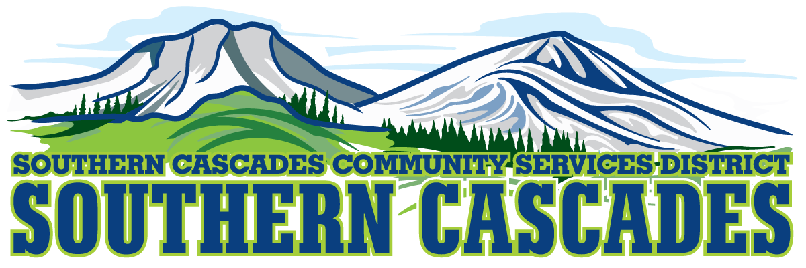
Conference Room
Southern Cascades Operations Base and Training Center
205 Ash Valley Road, Adin, CA 96006
May 15, 2023 5: 00 PM
Regular Board Meeting Agenda

- Call to Order

- Pledge of Allegiance

3.0 Roll Call and Establishment of a Quorum of the Board of Directors
4.0 Deletions /Additions and Approval of Agenda
5.0 Public Comment: This is the time set aside for citizens to address the Board on matters on the consent agenda and matters not otherwise on the agenda. Comments should be limited to matters within the jurisdiction of the Board. If your comment concerns an item shown on the agenda. Please address the Board after that item is open for public comment. By law, the Board cannot take action on matters that are not on the agenda. The chair reserves the right to limit the duration of each speaker to three minutes. The speaker may not cede their time.
Agenda items with times listed, will be considered at that time. All other items, will be considered as listed on the agenda or as deemed necessary by the Chairperson.

6.0 CLOSED SESSION- Per Government Code 54957, Public Employee Performance Evaluation- District General Administrator

7.0 Reconvene to Open Session
7.1 Instruction is given to staff as a result of Closed Session

8.0 Consideration/ Action
8.1 Approve proposal from Robert C. Province CPA for year end 2019 and 2020 financial audits

9.0 Information/Discussion
9.1 Community outreach mailer
9.2 Review amendments to Substance Abuse Policy #3520.0

10.0 Consent Agenda
10.1 Approve Regular Board Meeting minutes for April 17, 2023

11.0 Reports
11.1 Finance Committee Report
11.2 CFO Report
11.3 District Operations Analyst Report
11.4 Education Division Manager Report
11.5 HTS Supervisor Report
11.6 EMS Division Manager Report
11.7 District General Administrator Report
11.8 Board Reports

12.0 Correspondence

13.0 Adjournment

Parties with a disability as provided by the American Disabilities Act who require special accommodations or aides in order to participate in the public meeting should make the request by calling 530 299 3110 at least 24 hours prior to the meeting.

Posted at Southern Cascades Operations Base and Training Center Foyer and the SCCSD Web Site May 12, 2023.

